**Summary sheet**

Finalized Models

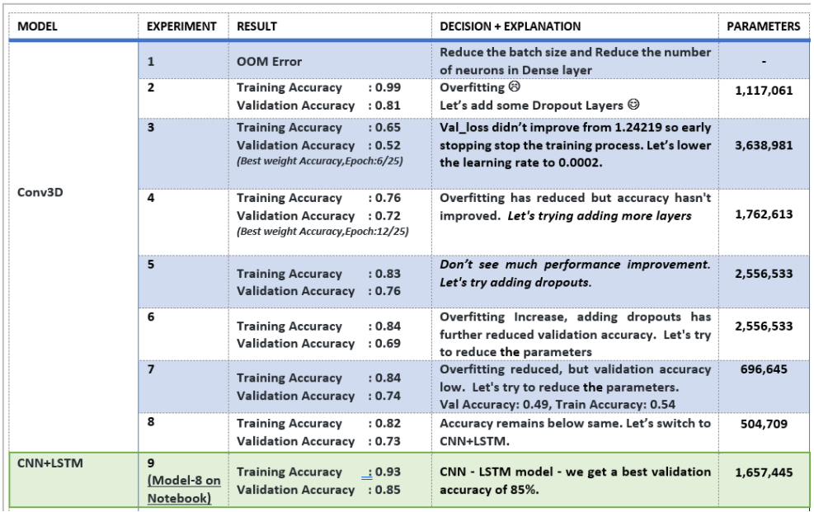

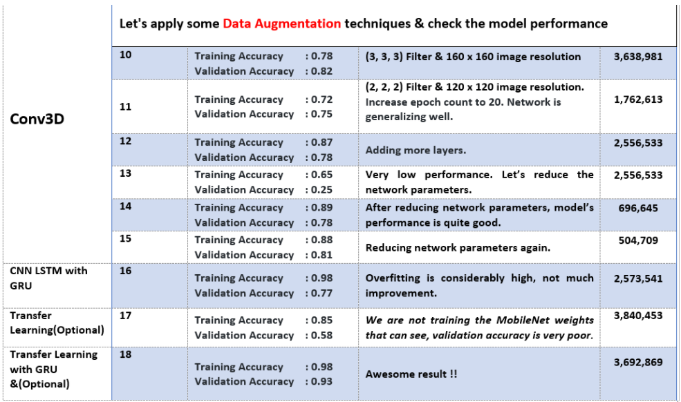

After doing all the experiments, we finalized Model 8 - CNN+LSTM, which performed well.

Reason:

- (Training Accuracy: 93%, Validation Accuracy: 85%)

- Number of Parameters (1,657,445) less according to other model performance

- Learning rate gradually decreasing after 16 Epoch

The best weights of CNN-LSTM: model-00001-1.82301-0.38989-2.91249-0.21000.h5 (19 MB). we considered this weight for model testing; Let's have look at the performance below